

Joy Wahome | Introduction to Computer | February 26, 2019

MY EXPERIENCE IN AKIRACHIX

# INTRODUCTION

This is a report about my experience in AkiraChix for the three weeks I have been here. This report will cover the units that I have been learning within the three weeks.

UNITS

1. Graphic Design

We learnt that Graphic Design is the art or skill of combining text and pictures in advertisements, pictures, logos and magazines. Graphic is visual therefore it I involves using visual elements like lines, colours, shapes and textures.

We have been practicing how to use the pen tool in Adobe Illustrator by tracing and colouring images. The main takeaway from the Graphic Design lesson is to be simple. Nyandia Kamawe is our lecturer.



2. Life Skills

Life Skills has been more of an interactive class where we share stories and reflect on our past experiences. In Life Skills, we learn to build our character and fireproof our inner core so as to be ready for whatever life throws at us. We also made vision boards. Veronica Nyokabi is our lecturer.



3. Hardware Electronics

So far, we have learnt about what electronics comprises of: circuits, physics and components. We have learnt about current, voltage, resistance and dividers and have done calculations on them. Barre Yassin is our lecturer.

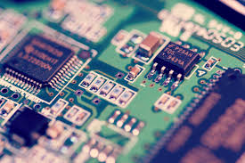

4. HTML & CSS

This unit is all about the front end development of a website. We have learnt how to make a HTML declaration and how to make a website with different sized headings and paragraphs. Jeff Muthondu is our lecturer.



5. Hardware Design

This class is all about identifying problems we experience and creating products to help solve those problems. We went through the stages of the design process and have begun learning about design thinking. Barre Yassin is our lecturer.

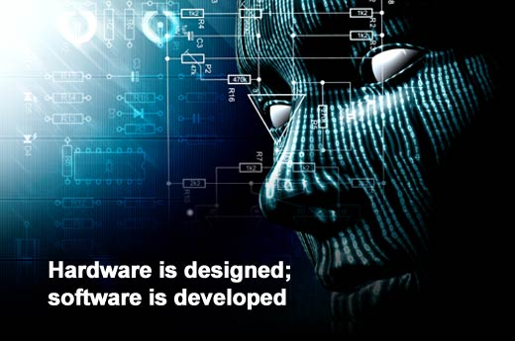

6. Introduction to Computers

In this unit, we have learnt about computers. How to operate them and how to handle them. We have learnt how to send e-mails, to use Microsoft Word, Microsoft Excel and to make slides using PowerPoint. We have also learnt how to use command prompt. Pascal Aloo is our lecturer.



7. Python

Python is a programming language. We have learnt about operators (arithmetic and comparison), data types, variables and string formatting. Sites like Instagram have been programmed using Python. James Mwai is our lecturer.

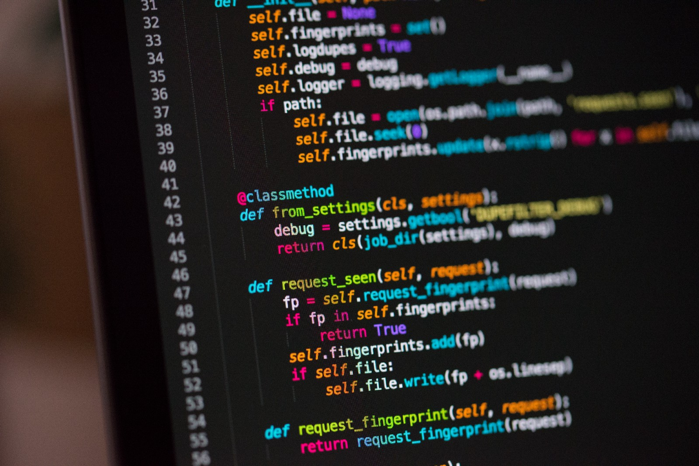

8. Entrepreneurship

We have learnt about the things an entrepreneur does, types of entrepreneurship and how they innovate. We also looked at the difference between innovation and invention. Kellie Murungi is our lecturer.



CONCLUSION

All in all, the experience at AkiraChix so far has been exciting and I believe that by the end of the year, I will have learnt enough to help me in the field I want to pursue after studies.